KPI QUERIES FIRED IN MS SQL SERVER

1. Total Loan Application

SELECT COUNT(id) AS total_loan_application FROM [bank loan]



1. MTD Loan Applications

SELECT COUNT(id) AS total_loan_application FROM [bank loan]

WHERE MONTH(issue_date) = 12 AND YEAR(issue_date) = 2021



1. PMTD Loan Applications

SELECT COUNT(id) AS PMTD_total_loan_application FROM [bank loan]

WHERE MONTH(issue_date) = 11 AND YEAR(issue_date) = 2021



1. SELECT SUM(loan_amount) AS TOTAL_AMONT_FUNDED FROM [bank loan]



1. SELECT SUM(loan_amount) AS TOTAL_AMONT_FUNDED FROM [bank loan]

WHERE MONTH(issue_date) = 12 AND YEAR(issue_date) = 2021



1. SELECT SUM(loan_amount) AS PMTD_TOTAL_AMONT_FUNDED FROM [bank loan]

WHERE MONTH(issue_date) = 11 AND YEAR(issue_date) = 2021



1. SELECT SUM(total_payment) AS PMTD_TOTAL_AMONT_Received FROM [bank loan]



1. SELECT SUM(total_payment) AS MTD_TOTAL_AMONT_Received FROM [bank loan]

WHERE MONTH(issue_date) = 12 AND YEAR(issue_date) = 2021



1. SELECT SUM(total_payment) AS PMTD_TOTAL_AMONT_Received FROM [bank loan]

WHERE MONTH(issue_date) = 11 AND YEAR(issue_date) = 2021



1. SELECT ROUND(AVG(int_rate),4)*100 AS Avg_int_rate FROM [bank loan]



1. SELECT ROUND(AVG(int_rate),4)*100 AS Mtd_Avg_int_rate FROM [bank loan]

WHERE MONTH(issue_date) = 12 AND YEAR(issue_date) = 2021



1. SELECT ROUND(AVG(int_rate),4)*100 AS Pmtd_Avg_int_rate FROM [bank loan]

WHERE MONTH(issue_date) = 11 AND YEAR(issue_date) = 2021



1. SELECT ROUND(AVG(dti),4)*100 AS Pmtd_Avg_dti_rate FROM [bank loan]

WHERE MONTH(issue_date) = 11 AND YEAR(issue_date) = 2021



1. SELECT ROUND(AVG(dti),4)*100 AS Mtd_Avg_dti_rate FROM [bank loan]

WHERE MONTH(issue_date) = 12 AND YEAR(issue_date) = 2021



1. SELECT

(COUNT(CASE WHEN loan_status='Fully Paid' OR loan_status = 'Current' THEN id END)*100)

/

COUNT (id) AS Good_Loan_Percentage

FROM [bank loan]



1. SELECT

(COUNT(CASE WHEN loan_status='Fully Paid' OR loan_status = 'Current' THEN id END)) AS Good_Loan_Applications

FROM [bank loan]

1. SELECT SUM(loan_amount) AS Good_Loan_Funded_Amount FROM [bank loan]

WHERE loan_status='Fully Paid' OR loan_status = 'Current'



1. SELECT SUM(total_payment) AS Good_Loan_Amount_Received FROM [bank loan]

WHERE loan_status='Fully Paid' OR loan_status = 'Current'



1. SELECT

(Count (CASE WHEN loan_status = 'Charged Off' THEN id END)*100)

/

COUNT(id) AS Bad_Loan_Percentage FROM [bank loan]



1. SELECT

Count (CASE WHEN loan_status = 'Charged Off' THEN id END)

AS Bad_Loan_Applications FROM [bank loan]



1. SELECT

SUM(loan_amount) AS Bad_Loan_Funded_Amount FROM [bank loan]

WHERE loan_status = 'Charged Off'



1. SELECT

SUM(total_payment) AS Bad_Loan_Received_Amount FROM [bank loan]

WHERE loan_status = 'Charged Off'



1. SELECT

loan_status,

Count(id) AS Total_Loan_Applications,

SUM(total_payment) AS Total_payment_received,

SUM(loan_amount)AS Total_Loan_Amount_Funded,

AVG(int_rate * 100) AS Average_Interest_Rate,

AVG(dti * 100) AS Averate_DTI

FROM [bank loan]

GROUP BY

loan_status

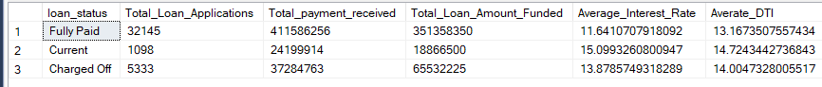

1. SELECT

loan_status,

SUM(total_payment) AS Total_AMOUNT_RECEIVED,

SUM(loan_amount) AS Total_Loan_Amount

FROM [bank loan]

WHERE MONTH(issue_date) = 12

GROUP BY

loan_status

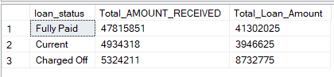

1. SELECT

MONTH(issue_date)AS Month_Number,

DATENAME(MONTH ,issue_date)AS Month_Name,

COUNT(id) AS Total_Loan_Applications,

SUM(loan_amount) AS Total_Funded_Amount,

Sum(total_payment) AS Total_Received_Amount

FROM [bank loan]

GROUP BY MONTH(issue_date), DATENAME (MONTH, issue_date)

ORDER BY MONTH(issue_date)

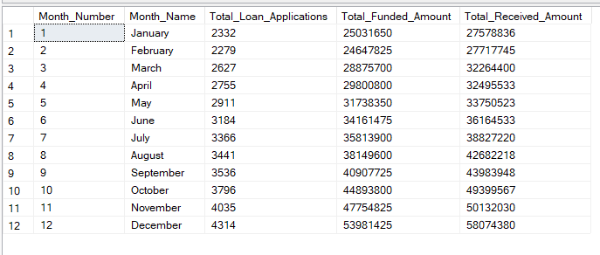

1. SELECT

address_state,

COUNT(id) AS Total_Loan_Applications,

SUM(loan_amount) AS Total_Funded_Amount,

Sum(total_payment) AS Total_Received_Amount

FROM [bank loan]

GROUP BY address_state

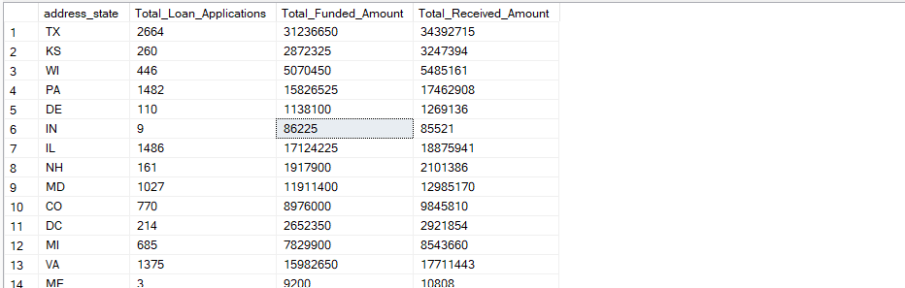

1. SELECT

term,

Count(id) As Total_Applications,

SUM(loan_amount) AS Total_Loan_Amount,

SUM(total_payment) AS Total_Amount_Received

FROM [bank loan]

GROUP BY term

ORDER BY term

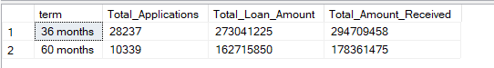

1. SELECT

emp_length,

Count(id) As Total_Applications,

SUM(loan_amount) AS Total_Loan_Amount,

SUM(total_payment) AS Total_Amount_Received

FROM [bank loan]

GROUP BY emp_length

ORDER BY count(id) DESC

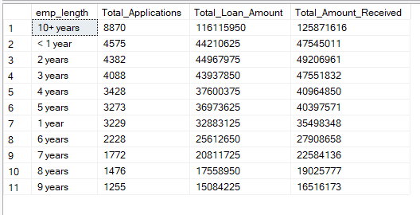

1. SELECT

purpose,

Count(id) As Total_Applications,

SUM(loan_amount) AS Total_Loan_Amount,

SUM(total_payment) AS Total_Amount_Received

FROM [bank loan]

GROUP BY purpose

ORDER BY count(id) DESC

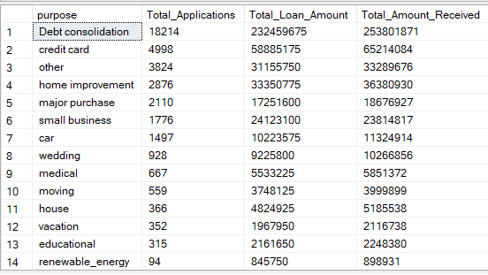

1. SELECT

home_ownership,

Count(id) As Total_Applications,

SUM(loan_amount) AS Total_Loan_Amount,

SUM(total_payment) AS Total_Amount_Received

FROM [bank loan]

GROUP BY home_ownership

ORDER BY count(id) DESC

